Logic Gates

L.O.: To understand what logic gates represent and the output of each gate

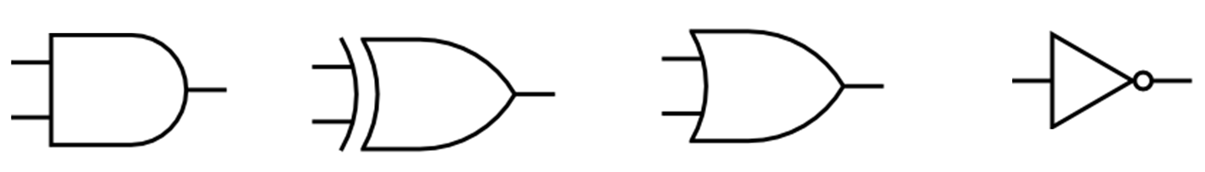

In order: AND, XOR, OR, NOT

Each logic gate, bar the NOT gate, take two inputs and provide one output.

|  |  |  |  |  |
| --- | --- | --- | --- | --- |
| *Logic Gate* | AND | OR | XOR | NOT |
| *Java Equivalent* | & | | | ^ | ! |

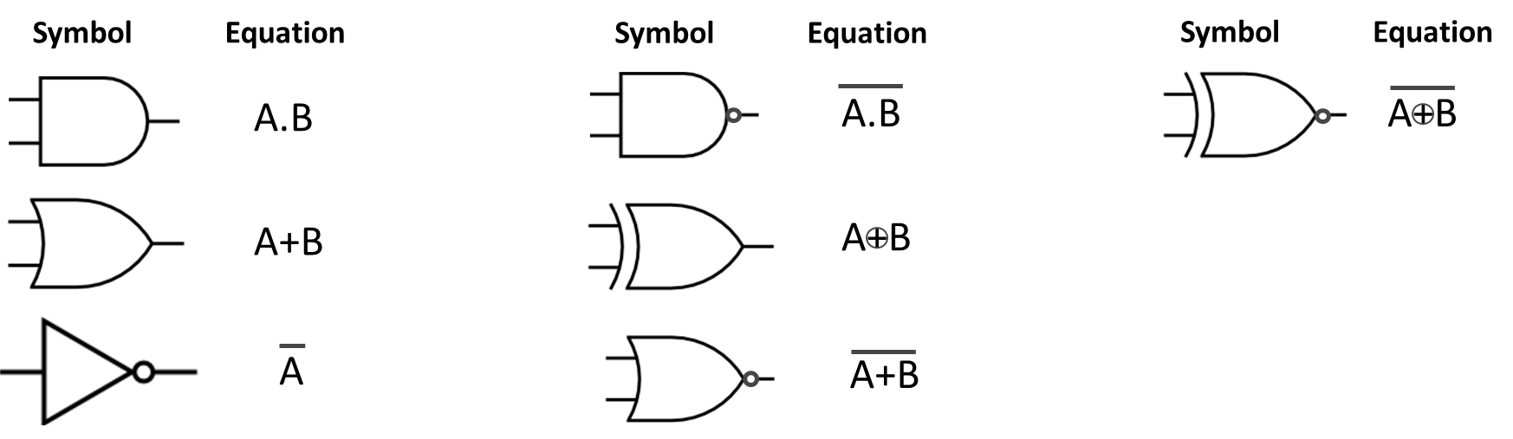

Logic gates can be expressed as Boolean logic:

|  |  |
| --- | --- |
| Symbol | Boolean expression |
| http://www.clker.com/cliparts/d/3/8/2/12065670311495995000nobody_Digital_logic_gates.svg.hi.png | !A |
| http://www.clker.com/cliparts/d/3/8/2/12065670311495995000nobody_Digital_logic_gates.svg.hi.png | A+B |
|  | A.B |
|  | AB |
|  | (A.B) . (C+D) |

|  |  |
| --- | --- |
| Symbol | Boolean expression |
|  | (A.B) . (CD) |
|  | A+B . C.D |
|  | (A+B) + (C.D) |

Some expressions are equivalent, for example, A.A = A, therefore A.A = A

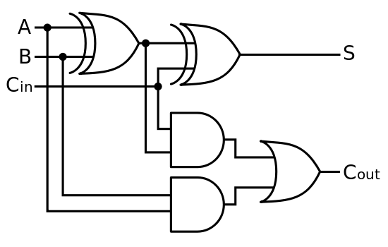

A Full Adder circuit.